August 2026 edition

Message from Professor Ian Chubb AC

Colleagues,
At our June meeting, we discussed strategic priorities for IGPRG, as well as next steps for the National One Stop Shop (NOSS), National Clinical Trials Governance Framework, and ethics accreditation.
The scope and ambition of NOSS and related national reforms remain unchanged. I am focused on leading improvements to the health and medical research operating and regulatory environment - further strengthening Australia's position as a leading destination for clinical trials. This work is more important than ever.
I look forward to continuing to progress this agenda with you.
Best wishes,
Ian
Chair, Inter-Governmental Policy Reform Group (IGPRG)

Single ethics review for research in Australia
We continue to work towards a future where a single ethics review decision is accepted forany health and medical research conducted in Australia.
Off the back of sector-wide consultation over recent years, feedback on the draft standards and options for Human Research Ethics Committee accreditation was sought in 2025.
Thank you to everyone who provided input.
A consultation report summarising the feedback has been published to the Australian Clinical Trials website. The feedback will be used to revise the standards and continue refining the accreditation model. A design delivery partner will be appointed to progress this work.

Consultation: NSQHS Standards (third edition)
The Australian Commission on Safety and Quality in Health Care has released an initial draft of the National Safety and Quality Health Service (NSQHS) Standards (third edition) for consultation.
The third edition incorporates the National Clinical Trials Governance Framework (NCTGF)and expands the focus on clinical research. This strengthens governance, accountability and support for research-enabled care across health services and recognises clinical research as a core component of modern health care delivery.
Implementation of NCTGF remains an important objective of national reforms to improve the consistency and predictability of the health and medical research operating environment.
Consultation closes on 25 September 2026. For more information and to have your say on the draft third edition, please visit the NSQHS Standards (third edition) engagement hub.

National One Stop Shop update
On 12 May 2026, the Australian Government announced funding to progress national clinical trials reforms, including the next stage of the National One Stop Shop (NOSS).
The scope and ambition of the national reforms, including NOSS, remains unchanged. Work to appoint a NOSS solution partner is underway. We are also working to finalise the detailed system architecture and data strategy to ensure a seamless transition.

Q&A from the ARCS Annual Conference 2026
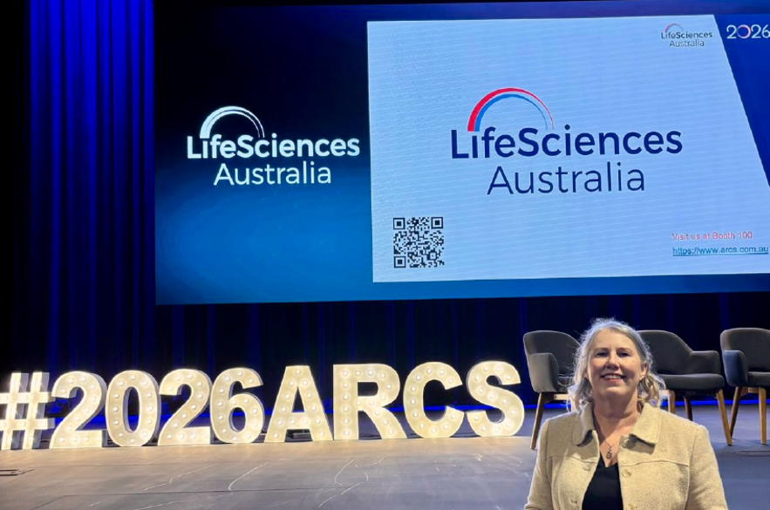
Photo: Linda Cristine (DHDA) at the ARCS Annual Conference 2026
In June 2026, the Department of Health, Disability and Ageing presented at the ARCS Annual Conference. The following thoughtful questions from attendees received during the session are answered here.

What will NOSS be used for?
NOSS will provide a single national platform for health and medical research in Australia, including clinical trials and teletrials. It is intended to streamline research approvals and related processes, reduce duplication and make it easier for clinicians, patients, researchers and sponsors to find, conduct and participate in research. This includes supporting ethics review, site authorisation, relevant regulatory requirements, trial registration, reporting and research management functions.

Who will have access to confidential information in NOSS?
Access to information in NOSS will be managed through secure authentication and rolebased permissions. Authorised users will only be able to access the documents and information relevant to their role, organisation and project. The system is being designed to protect privacy, data security and commercial-in-confidence information, including by allowing access to be restricted to specific user profiles where needed.

Will safety reporting occur through NOSS?
NOSS is being developed as an approvals, workflow and research information system. It is expected to support relevant post-approval and monitoring functions, including safety reporting.

Will NOSS allow users to search and extract data (like ANZCTR does now)?
NOSS will offer functionality that is currently available on ANZCTR. It will include an embedded national clinical trials registry and a public-facing component so people can search for relevant trials and research. NOSS is also intended to provide reporting and data functions for authorised users. Public access to searchable trial information will remain an important feature.

Will existing data from ANZCTR and jurisdictional ethics review systems be migrated across to NOSS?
A comprehensive data migration strategy is being developed in consultation with jurisdictions to support a smooth transition to NOSS. The approach will consider existing jurisdictional systems, ANZCTR data and the status of current research.

How will NOSS address regulatory fragmentation?
NOSS is part of a broader national reform agenda to strengthen, harmonise and streamline health and medical research in Australia. It will help address fragmentation by bringing key application, approval, notification, registration and reporting processes into one national system. Related reform activity will focus on modernising and harmonising current processes ahead of NOSS implementation.

How will regional, rural and remote (RRR) communities benefit from NOSS?
NOSS will help reduce administrative burden and support more consistent research processes across health systems, including in rural, regional and remote areas. By creating a single national platform and improving visibility of research activity, NOSS can support better planning, coordination and access to research. To support these efforts to improve equity and access, including research participation and capability in rural, regional and remote communities, an Access & Equity Strategy will also be developed.

What is the timeframe for NOSS delivery?
The 2026-27 Budget provides funding to progress the next stage of NOSS and related national reforms, including work to identify an ICT solution partner. Once a solution partner is engaged, detailed delivery timeframes will be confirmed. Current planning anticipates building the platform could take around 18 months or more after appointment of the solution partner. Proposed timeframes are subject to Government decisions.

Consultation: MRFF Strategy (2026-31) and Priorities (2026-28)
The Australian Medical Research Advisory Board is seeking input on the draft Australian Medical Research and Innovation Strategy (2026-31) and Australian Medical Research and Innovation Priorities (2026-28), which will guide future investment from the Medical Research Future Fund (MRFF).
Stakeholders are invited to provide feedback on the draft MRFF Strategy and Priorities via a survey on the Department of Health, Disability and Ageing consultation hub by 16 August 2026.

EOI: Delphi consensus study to determine an Australian clinical research competency framework
NSW Health is seeking expressions of interest from people who would like to participate in a Delphi consensus study to help determine an Australian clinical research competency framework. The project aims to generate consensus on a national framework to support training, recruitment, management and development of the clinical research workforce.
Expressions of interest are open until 24 August 2026.

National Health and Medical Research Strategy 2026-2036
In May 2026, the Minister for Health and Ageing and the Minister for Disability and the National Disability Insurance Scheme, the Hon Mark Butler MP, announced the release of the National Health and Medical Research Strategy 2026-2036 (the National Strategy).
...Read more

Good Clinical Practice Inspection Program Metrics Report 2025
The Therapeutic Goods Administration (TGA) has published outcomes from inspections conducted under the Good Clinical Practice (GCP) Inspection Program from 1 January 2025 to 31 December 2025.
...Read more

HREA v1.6 and NHMRC National Statement update
The Human Research Ethics Application (HREA) has been updated to version 1.6 to align with the revised National Statement on Ethical Conduct in Human Research (2025) (the National Statement).
...Read more

ISO 14155:2026 Clinical investigation of medical devices for human subjects – Good clinical practice
ISO 14155:2026 was published in March 2026. To allow stakeholders time to consider the updated requirements, the TGA has applied a 12-month transition period from the date of publication (31 March 2026 to 31 March 2027).
...Read more

Stay connected. Stay informed. Stay involved.
For more information about clinical trials in Australia, visit the Australian Clinical Trials website.
To get in touch, please email: ClinicalTrialsPolicy@health.gov.au.
If you received this newsletter from the Department of Health, Disability and Ageing, you have already subscribed to receive updates on the national clinical trials reforms.
You can subscribe to receive regular updates on the national reforms.
Follow us Facebook LinkedIn X (Twitter) Youtube Instagram
We acknowledge the Traditional Owners and Custodians of Country throughout Australia, and their continuing connection to land, sea and community. We pay our respects to them and their cultures, and to Elders both past and present.
© Commonwealth of Australia | Department of Health, Disability and Ageing
Disclaimer Privacy Unsubscribe from our mail list

